- Flowchart:

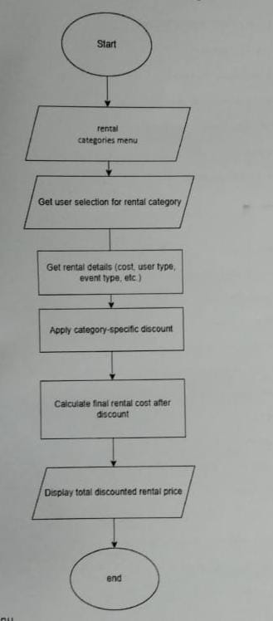

2. Algorithm:
- Start
- Display rental categories menu
- Get user selection for rental category
- Based on the selected category:
  - Get rental details (cost, user type, event type, etc.)
  - Apply category-specific discount
  - Calculate the final rental cost after discount
- Display the total discounted rental price
- End
3. Pseudocode:
BEGIN
DISPLAY "Welcome to Al-Faiz Rent A Car System"
DISPLAY "Select the type of rental:"
DISPLAY "1. Health and Wellness Rentals"
DISPLAY "2. Academic and Educational Rentals"
DISPLAY "3. Recreational and Adventure Rentals"
DISPLAY "4. Sports Rentals"
DISPLAY "5. Family and Social Rentals"
INPUT choice

IF choice == 1 THEN
INPUT relation, rent
CALCULATE discount FOR health and wellness rentals
DISPLAY final rental cost
ELSE IF choice == 2 THEN
INPUT category, rentalType, university
CALCULATE discount FOR academic and educational rentals
DISPLAY final rental cost
ELSE IF choice == 3 THEN
INPUT rentalCost, role
CALCULATE discount FOR recreational and adventure rentals
DISPLAY final rental cost
ELSE IF choice == 4 THEN
INPUT rentalCost, sportsRental, eventType
CALCULATE discount FOR sports rentals
DISPLAY final rental cost
ELSE IF choice == 5 THEN
INPUT rentalCost, socialRentals, role, eventType, eventLocation
CALCULATE discount FOR family and social rentals
DISPLAY final rental cost
ELSE
DISPLAY "Invalid Choice!"
ENDIF
END

